Test Case: tc003_SPX_Dev5_Crear_Requisicion_Spot_Tipo_Cobro_CC_Urgent
Step 1 - Enter username and password and click to button Enter : Credentials Entered
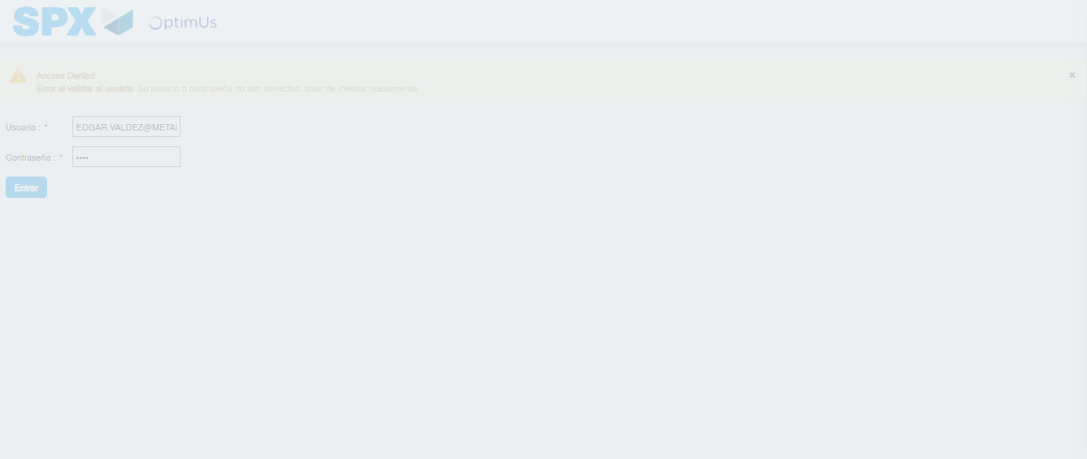Image file-name: QC_Testing-tc003_SPX_Dev5_Crear_Requisicion_Spot_Tipo_Cobro_CC_Urgent-1781646420102

Step 2 - Select to UEN and Access to Spot Buy Requisitions : UEN Correctly selected and Correct access
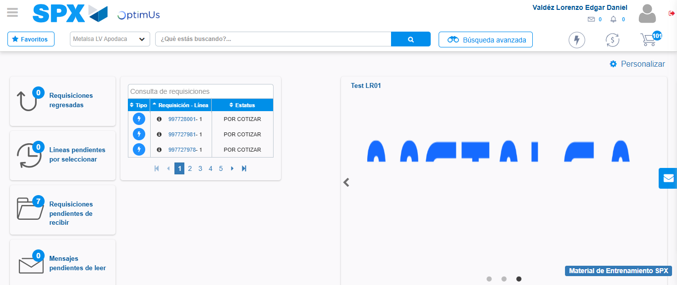Image file-name: QC_Testing-tc003_SPX_Dev5_Crear_Requisicion_Spot_Tipo_Cobro_CC_Urgent-1781646446507

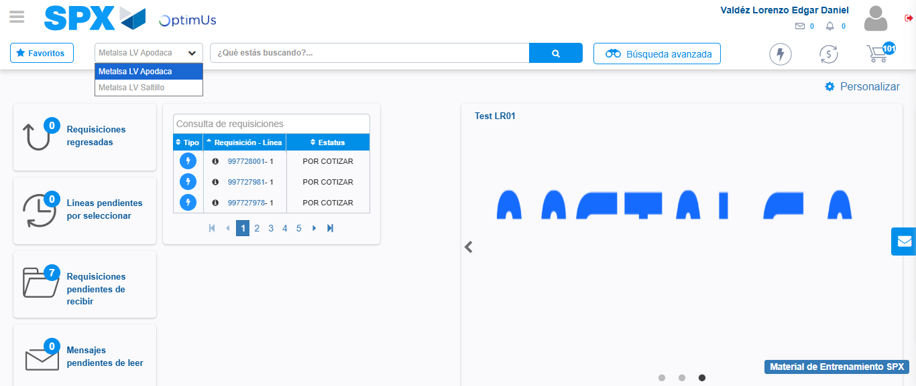Image file-name: QC_Testing-tc003_SPX_Dev5_Crear_Requisicion_Spot_Tipo_Cobro_CC_Urgent-1781646449341

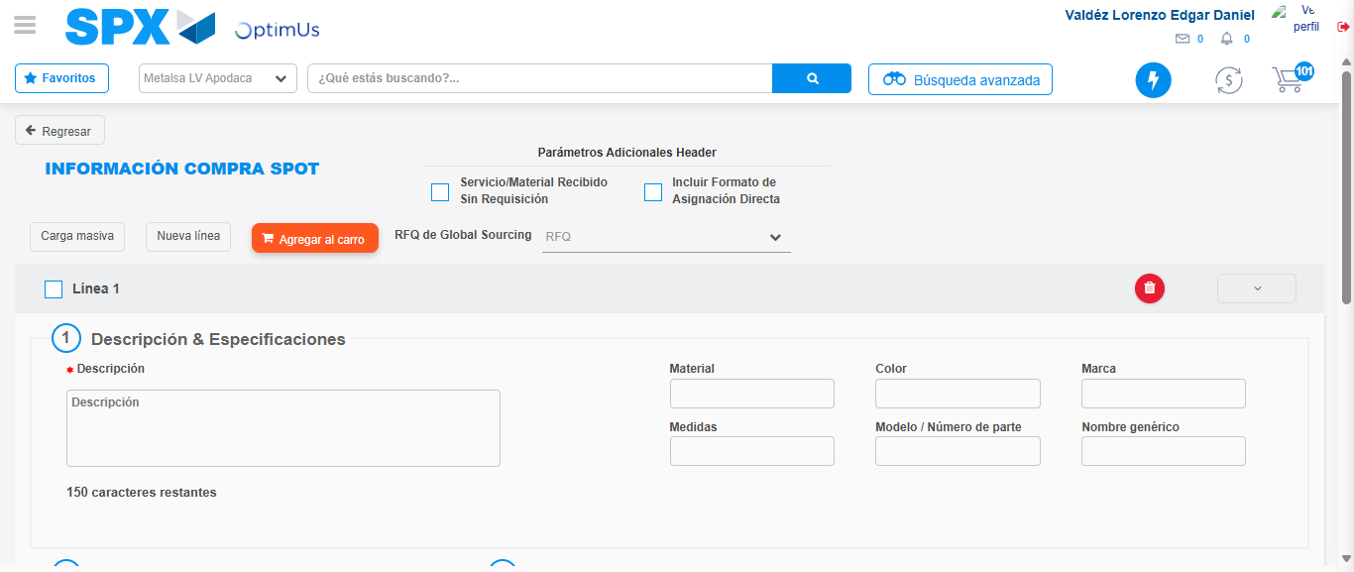Image file-name: QC_Testing-tc003_SPX_Dev5_Crear_Requisicion_Spot_Tipo_Cobro_CC_Urgent-1781646471617

Step 3 - Data Capture Spot Buy Requisition: Data captured correctly
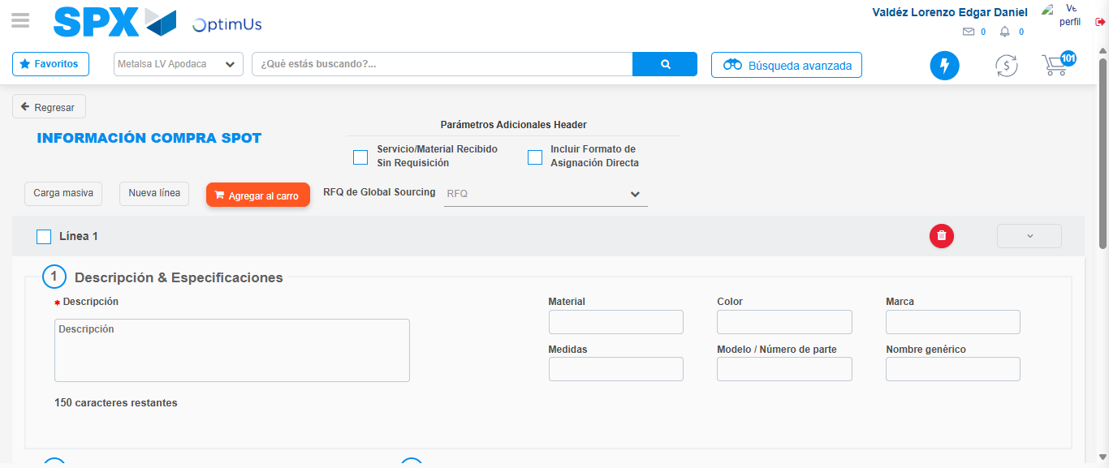Image file-name: QC_Testing-tc003_SPX_Dev5_Crear_Requisicion_Spot_Tipo_Cobro_CC_Urgent-1781646471937

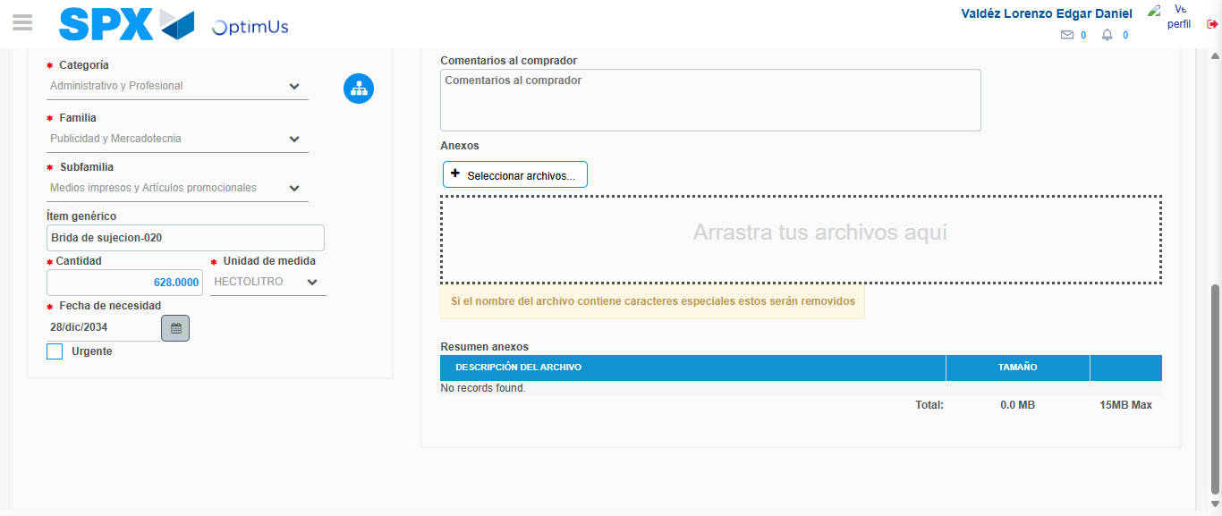Image file-name: QC_Testing-tc003_SPX_Dev5_Crear_Requisicion_Spot_Tipo_Cobro_CC_Urgent-1781646485309

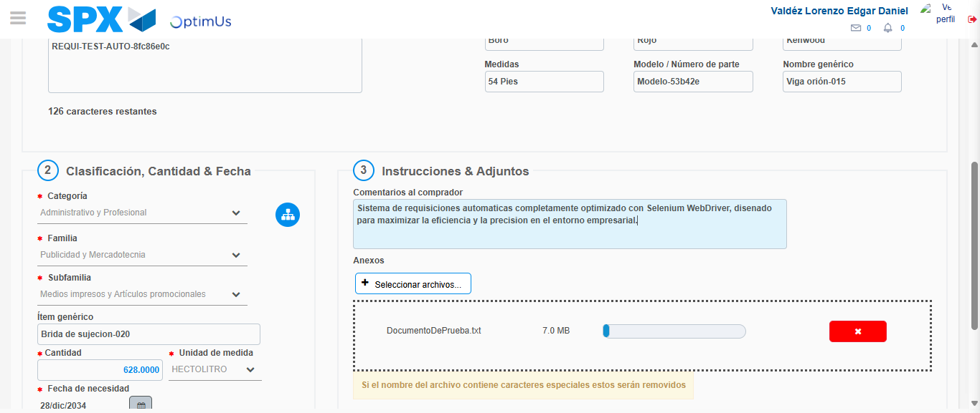Image file-name: QC_Testing-tc003_SPX_Dev5_Crear_Requisicion_Spot_Tipo_Cobro_CC_Urgent-1781646486257

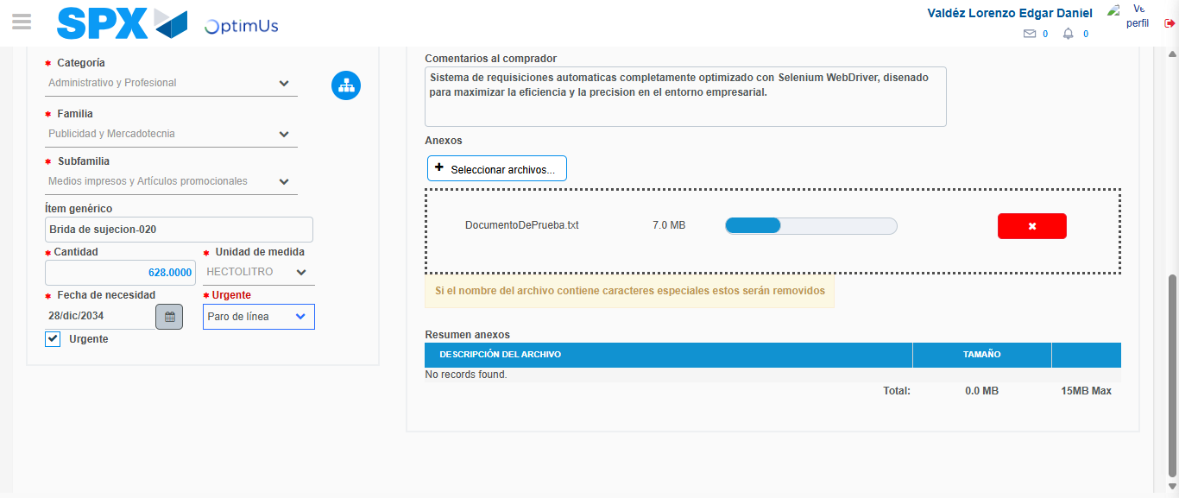Image file-name: QC_Testing-tc003_SPX_Dev5_Crear_Requisicion_Spot_Tipo_Cobro_CC_Urgent-1781646490039

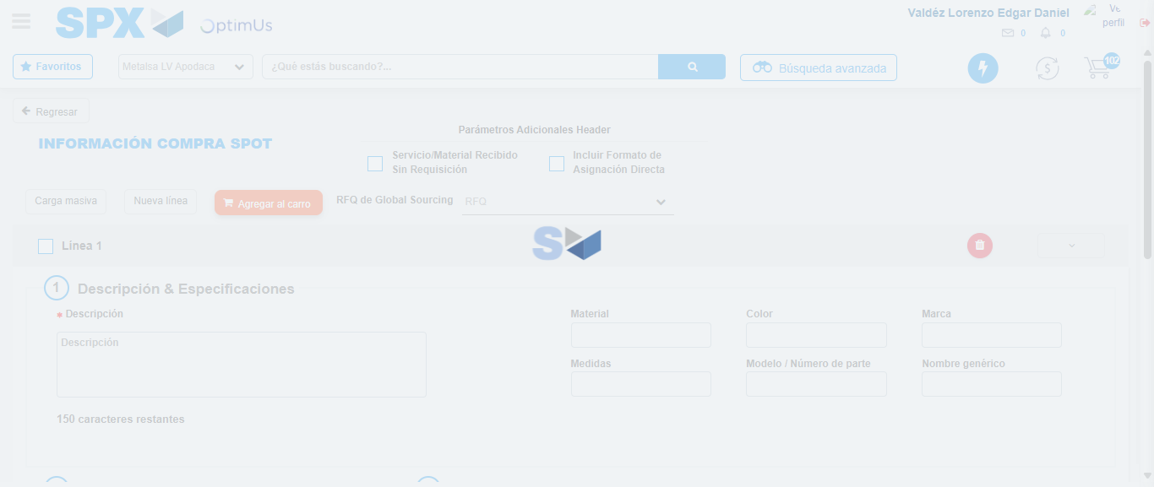Image file-name: QC_Testing-tc003_SPX_Dev5_Crear_Requisicion_Spot_Tipo_Cobro_CC_Urgent-1781646492302

Step 4 - Select to Requisition: Requisition Correctly selected
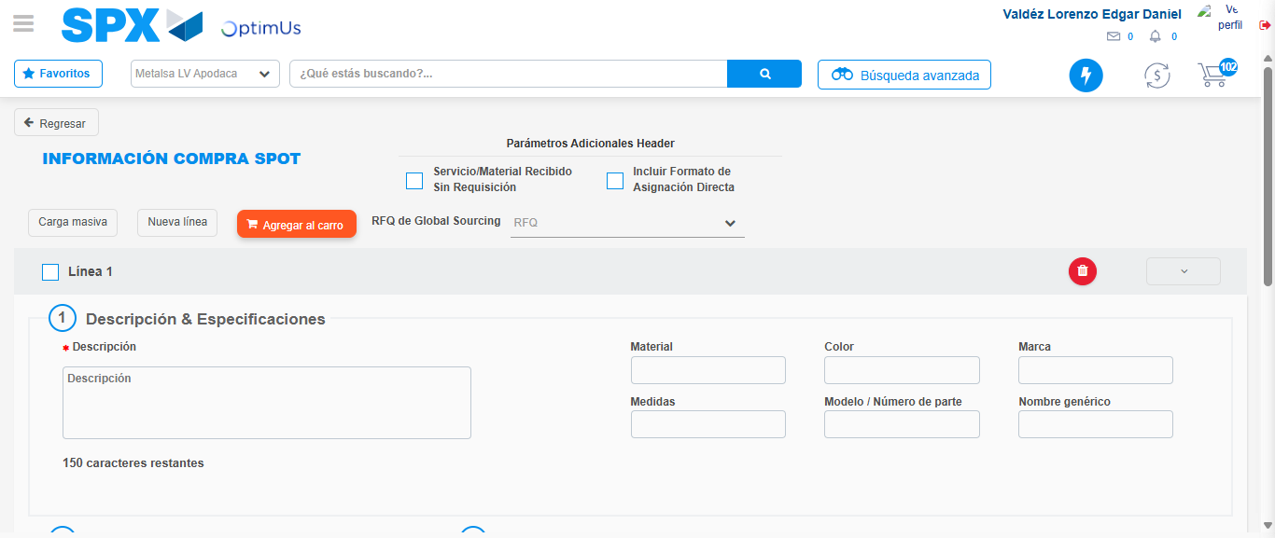Image file-name: QC_Testing-tc003_SPX_Dev5_Crear_Requisicion_Spot_Tipo_Cobro_CC_Urgent-1781646492571

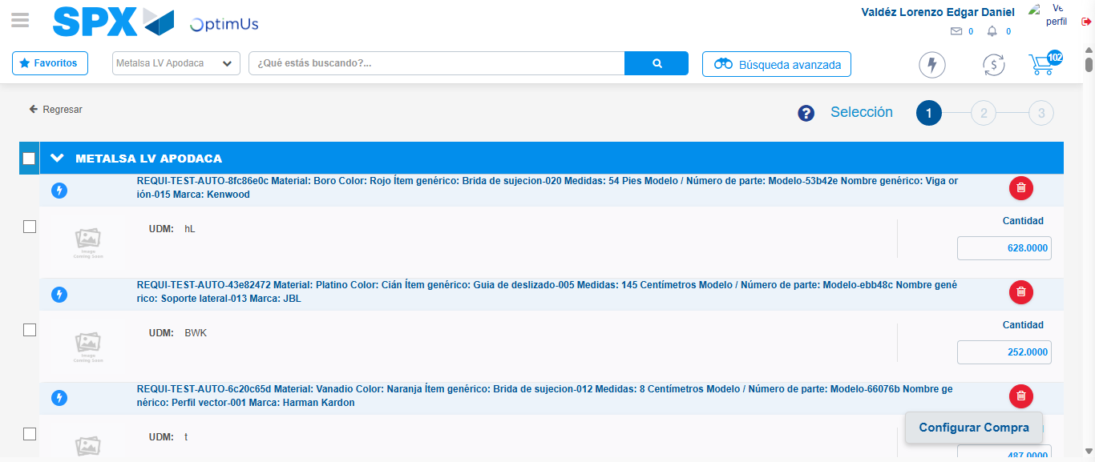Image file-name: QC_Testing-tc003_SPX_Dev5_Crear_Requisicion_Spot_Tipo_Cobro_CC_Urgent-1781646500520

Image file-name: QC_Testing-tc003_SPX_Dev5_Crear_Requisicion_Spot_Tipo_Cobro_CC_Urgent-1781646500796

Image file-name: QC_Testing-tc003_SPX_Dev5_Crear_Requisicion_Spot_Tipo_Cobro_CC_Urgent-1781646501048

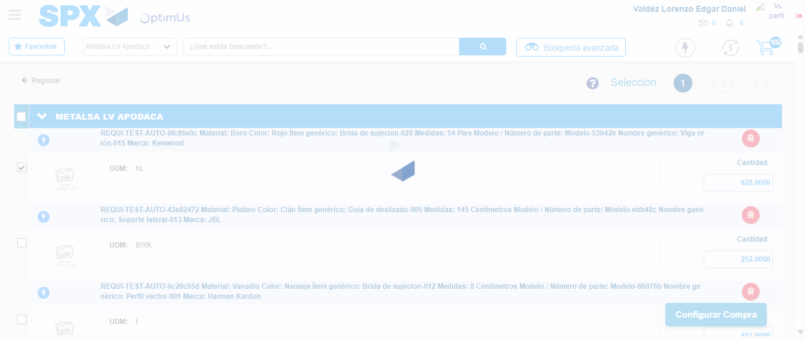Image file-name: QC_Testing-tc003_SPX_Dev5_Crear_Requisicion_Spot_Tipo_Cobro_CC_Urgent-1781646502202

Step 5 - Select Type Account For Requisition: Type Account Correctly selected
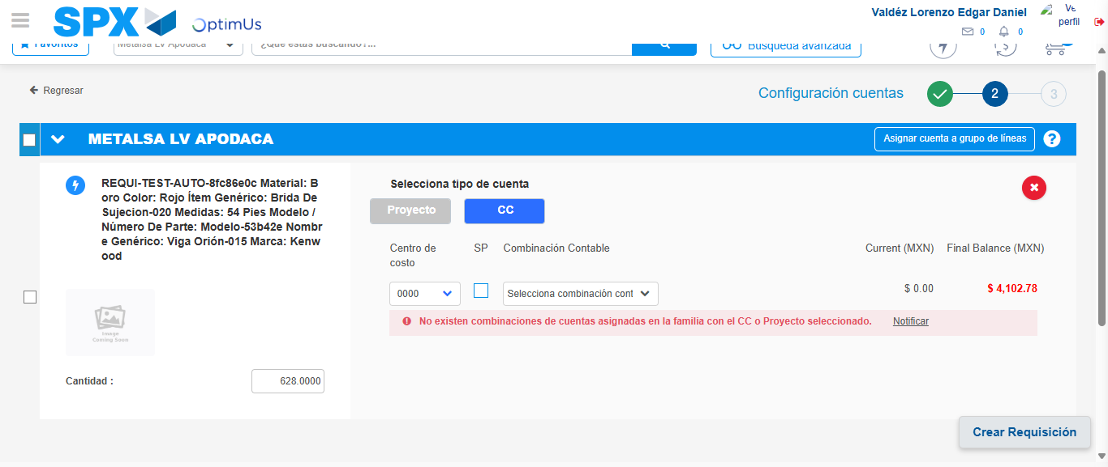Image file-name: QC_Testing-tc003_SPX_Dev5_Crear_Requisicion_Spot_Tipo_Cobro_CC_Urgent-1781646530322

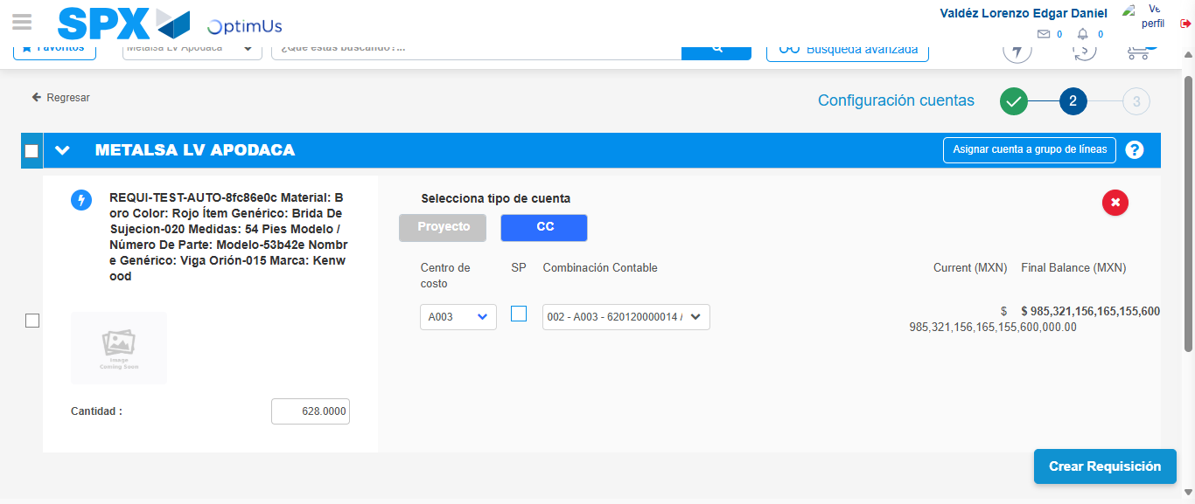Image file-name: QC_Testing-tc003_SPX_Dev5_Crear_Requisicion_Spot_Tipo_Cobro_CC_Urgent-1781646543251

Image file-name: QC_Testing-tc003_SPX_Dev5_Crear_Requisicion_Spot_Tipo_Cobro_CC_Urgent-1781646543416

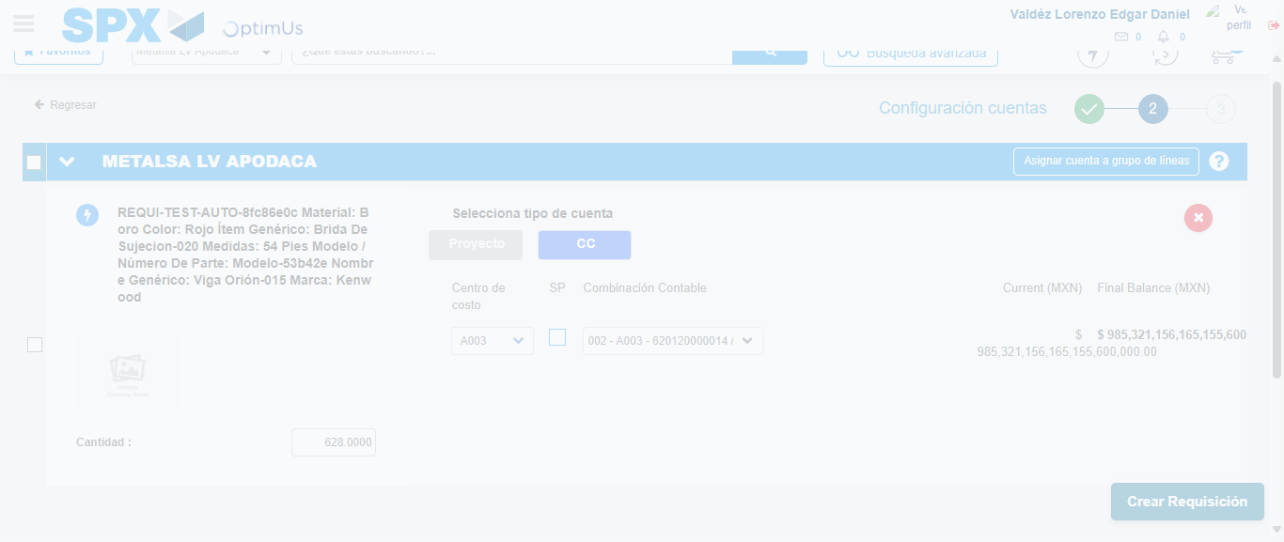Image file-name: QC_Testing-tc003_SPX_Dev5_Crear_Requisicion_Spot_Tipo_Cobro_CC_Urgent-1781646543805

Step 6 - Accept to Requisition: Requisition Accepted
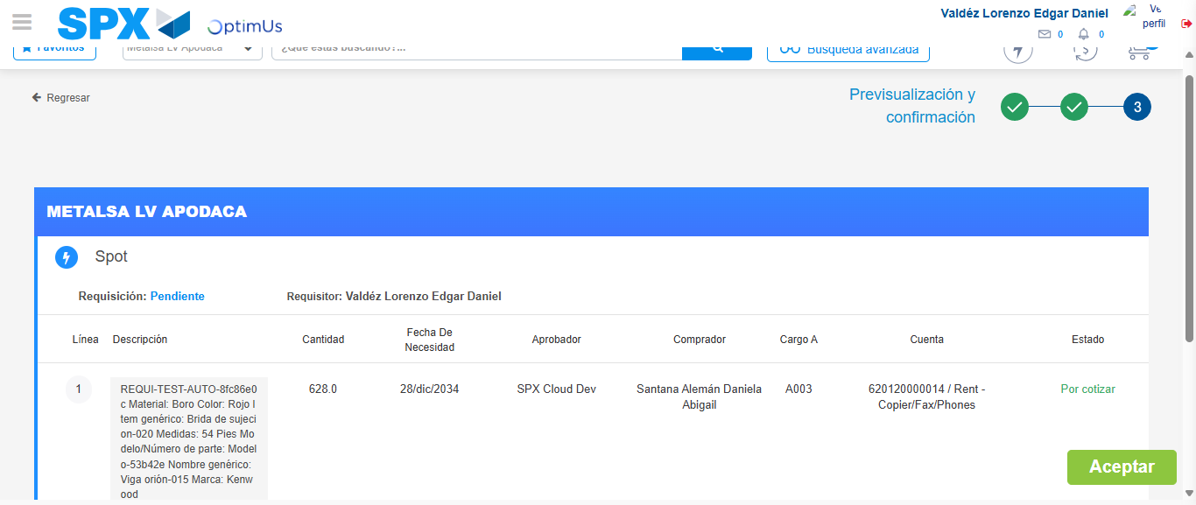Image file-name: QC_Testing-tc003_SPX_Dev5_Crear_Requisicion_Spot_Tipo_Cobro_CC_Urgent-1781646545090

Image file-name: QC_Testing-tc003_SPX_Dev5_Crear_Requisicion_Spot_Tipo_Cobro_CC_Urgent-1781646545310

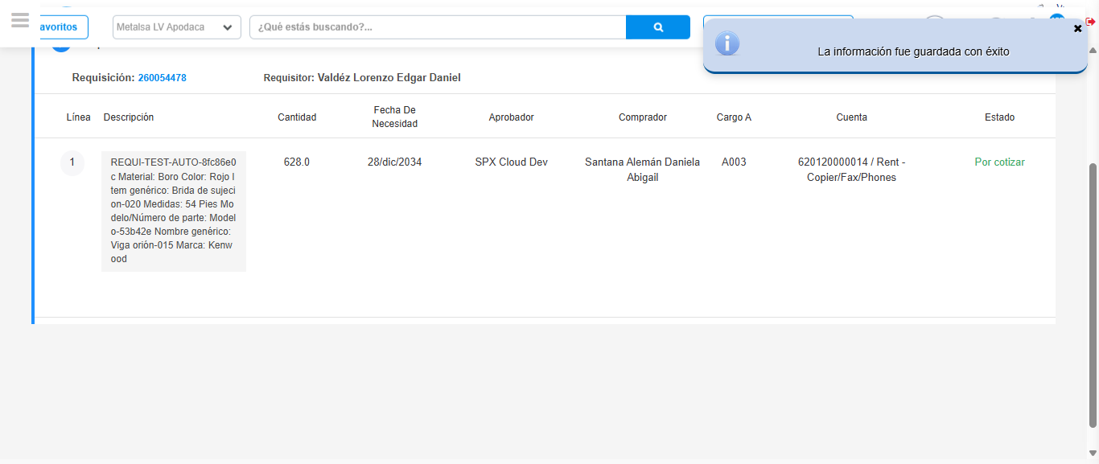Image file-name: QC_Testing-tc003_SPX_Dev5_Crear_Requisicion_Spot_Tipo_Cobro_CC_Urgent-1781646548791

Step 7 - Return to Main Page SPX : Return to Main Page SPX
Image file-name: QC_Testing-tc003_SPX_Dev5_Crear_Requisicion_Spot_Tipo_Cobro_CC_Urgent-1781646446507

Image file-name: QC_Testing-tc003_SPX_Dev5_Crear_Requisicion_Spot_Tipo_Cobro_CC_Urgent-1781646449341

Image file-name: QC_Testing-tc003_SPX_Dev5_Crear_Requisicion_Spot_Tipo_Cobro_CC_Urgent-1781646471617

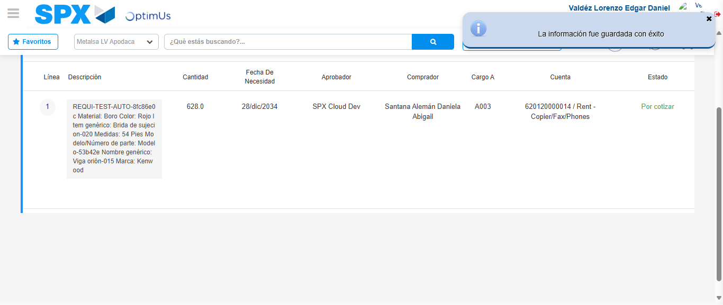Image file-name: QC_Testing-tc003_SPX_Dev5_Crear_Requisicion_Spot_Tipo_Cobro_CC_Urgent-1781646551016

Image file-name: QC_Testing-tc003_SPX_Dev5_Crear_Requisicion_Spot_Tipo_Cobro_CC_Urgent-1781646551208

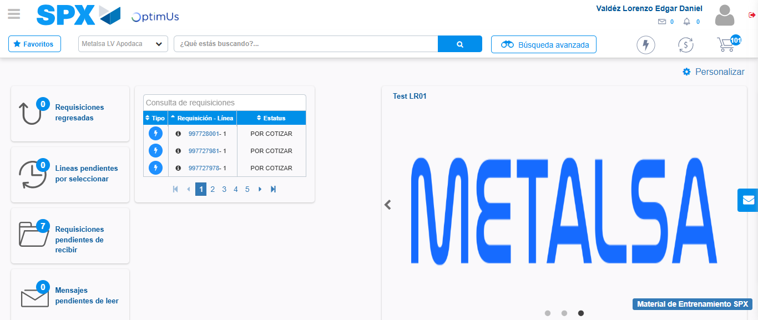Image file-name: QC_Testing-tc003_SPX_Dev5_Crear_Requisicion_Spot_Tipo_Cobro_CC_Urgent-1781646572378

Step 8 - Log Out : Log Out SPX
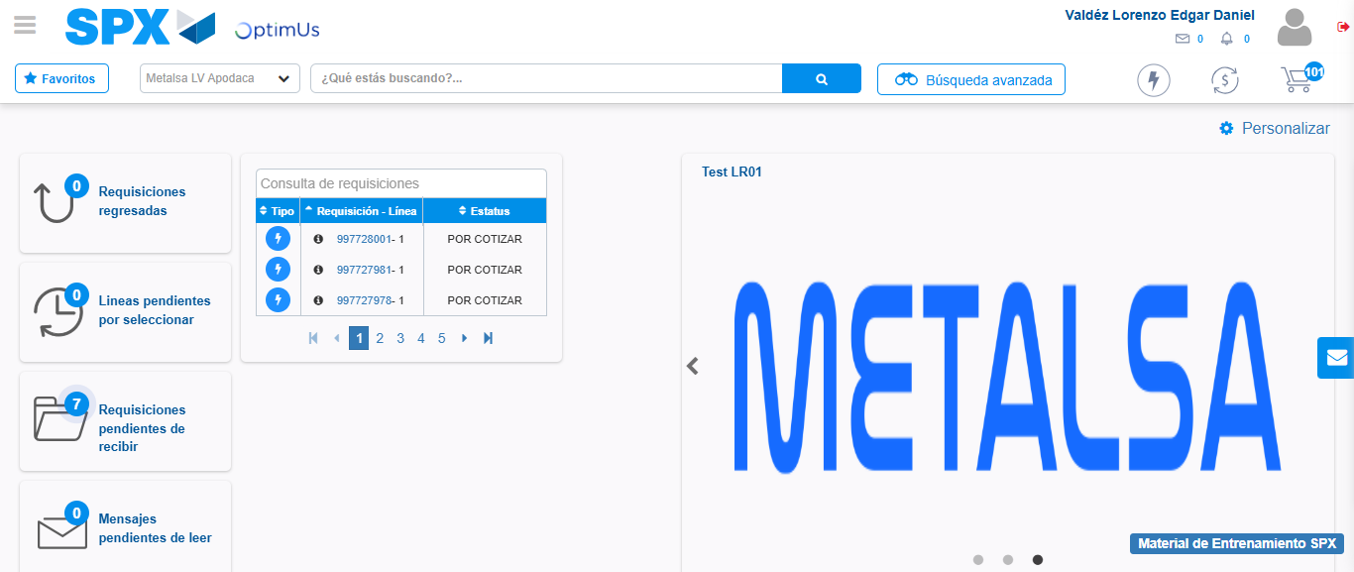Image file-name: QC_Testing-tc003_SPX_Dev5_Crear_Requisicion_Spot_Tipo_Cobro_CC_Urgent-1781646572697

